



**College of**

**Human Medicine**

Master of

Public Health

Division of

Public Health

Capitol Theatre

130 E. 2nd Street

Suite 202  
Flint, MI 48502

810-600-5601

FAX: 810-600-9171

mph.msu.edu

MSU is an affirmative-action,

equal-opportunity employer*.*

**MSU is an affirmative-action,**

**equal-opportunity institution.**

Monday, February 7, 2022

To Whom it May Concern.

I highly recommend Gergana Yordanova as a candidate for Ford Motor Company. I have worked with Gergana in my capacity as Instructional Technology and Design Supervisor at Michigan State University College of Human Medicine, Master of Public Health program.

While a student at Michigan State University Gergana has maintained a 3.7 GPA while taking a full load of courses. She excels as a top student at Michigan State University and seeks to continue her pursuit of a degree in User Experience Architecture (UX) from the College of Arts and Letters.

In addition to her course work, Gergana is also employed with the Master of Public Health (MPH) online program as our Instructional Technology and Accessibility Intern. She has assisted in instructional technology and design, creation of digital products, coding, research, and communications, while assisting faculty in MPH courses.

Faculty and staff in the program speak highly of her performance and assistance in assuring needs are met, concerns are addressed promptly, and UX needs are quickly completed in their online course.

Gergana has accomplished all these tasks with great initiative and a positive attitude. She never turns down a request from faculty or staff. When in need of assistance, she requests support, never leaving a task incomplete. This in my world is the sign of great leader.

Gergana would be a tremendous asset in any industry, her care and compassion for her colleagues are unrivaled in this Public Health program and I recommend her to you without reservation. If you have any questions or concerns about her background or qualifications, please do not hesitate to contact me.

Sincerely,

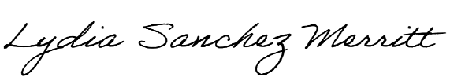

Lydia Sanchez Merritt, M.A.I.T.

D2L and Curriculum Support Coordinator, Michigan State University   
810-600-5634